Mini-Lessons
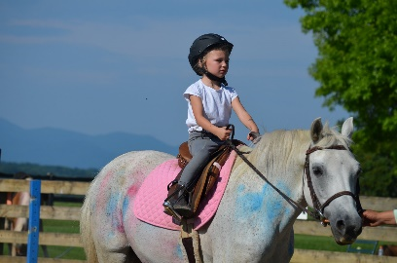
Geared towards 3 to 6 year olds; this is a great way to introduce young kids to horses. During their lessons children will groom, tack, learn about where horses live, barn and horse safety, and have a 15 minute “mini” lesson. Cost is $22 per lesson or a package of four is $80. Please contact Stacey to schedule a lesson.
Boarding
Harmony Equestrian Center, LLC offers high quality, full care for your equine partner. HEC offers daily turnout, a large ring with jumps, exceptional care, beautiful surroundings, and most importantly – an environment where learning and improving the bond with your horse is nurtured. We offer stall and pasture board. All board options include lessons or training sessions. Board begins at $415/month for pasture and $30/month for stall. For more details and to set up a tour of HEC’s facilities, please contact Stacey at 978-618-3273 or email her at stacey@harmonyequestriancenter.com.

Leasing
For riders that are looking to increase their involvement with horses, but are not ready to own, leasing is a great option. With leasing you get all the benefits of owning your own horse, but with less time and financial commitment. All our leasing options include weekly lessons and practice rides. Our leases begin at $425/month with 2 lessons and 1 practice ride per week. Please talk to Stacey if you are interested in more information.

Our Location
Harmony Equestrian Center, LLC is conveniently located at 661 Farmers Road, Fincastle. From I-81north, take Exit 156, turn left at the end of the ramp onto Brughs Mill Road; from I-81 south, turn right at the end of the ramp onto Brughs Mill Road. Drive about 1 mile and turn right onto Farmers Road. The driveway for HEC is about 1/2 mile on the left. Drive up gravel drive, at top of hill, turn right, drive on brick drive past the house, and park in the gravel barn lot. Ship-ins welcome.
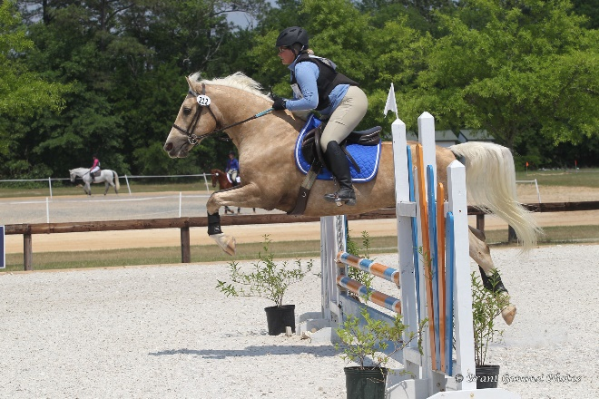
To set up a lesson, tour, or if you have further questions, please feel free to contact Stacey Collins by phone at 978-618-3273 or email at stacey@harmonyequestriancenter.com.

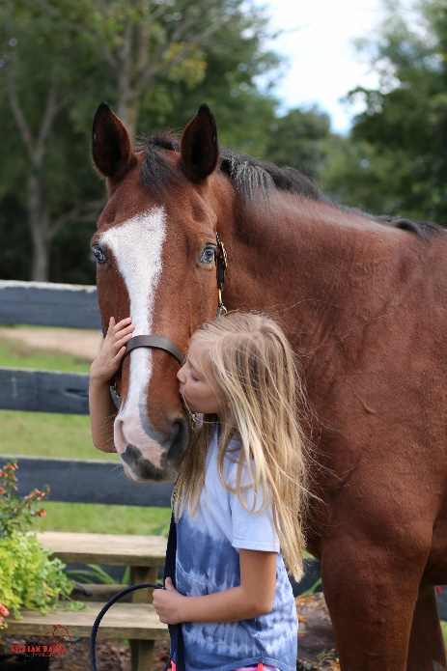

Informational Brochure
*Prices Subject to Change
Welcome!
Harmony Equestrian Center, LLC offers a top-notch, quality, equestrian education for beginners through advanced riders in a family friendly environment. We teach not only riding, but also the day to day aspects of horse care, creating a well rounded, responsible horseperson.
Whether you are just beginning to ride, getting back into the saddle after a hiatus, or looking to advance your riding skills, we can help you reach your goals. We have quality, kid friendly, beginner safe, school horses as well as advance school horses able to help you get back in the competition ring.

Meet Our Team
Harmony Equestrian Center’s team is made up of highly skilled, professional horse people. Our team will help you learn the ins and outs of horsemanship and riding. They also give our horse friends the best care.

Abby Long, Manager: As a kid Abby loved to be around horses and learned as much as she could from anyone who would teach her. As an adult she has worked at several local stables, and now we are lucky enough to have her at Harmony taking care of our beloved 4-legged friends.

Peyton Stevenson, Teacher/Assistant: Peyton began riding in the Roanoke Valley as a kid. Knowing she wanted to have a career in horses, after high school, she attended Meredith Manor in West Virginia. After completing her education at Meredith Manor, Peyton has been working in various aspects of the equine industry. Harmony is please to have her as part of the team teaching students and working with horses.

Stacey Collins, Owner/Teacher: Stacey grew up in western New York riding horses and helping out at barns. After getting her degree from UMass Amherst she taught horseback riding in Massachusetts for 14 years, running a large riding program for 10 years. In 2009, Stacey and her family moved to Virginia, where she opened Harmony Equestrian Center, LLC in 2010.

LESSON PRICES
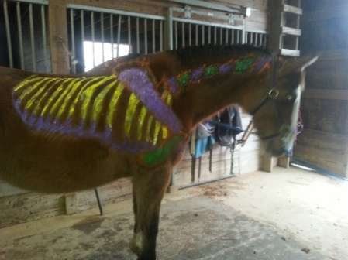
HEC offers 30 minute or 60 minute private lessons or 60 minute group lessons.
Lesson Length | Individual Lesson Price
30 minute private | $40
60 minute private | $75
60 minute group (2-4 people) | $40 per person

Lessons may also be purchased in 8 lesson packages. Packages must be used within 10 weeks. 24 hour cancelation is required in order to make up the lesson within the 10 weeks. Any lesson canceled late may result in loss of that lesson.
Lesson Length | 8 Lesson Package Price
30 minute private | $288.00
60 minute private | $540.00
60 minute group | $288.00 per person

Summer Programs
In addition to year-round lessons, we offer summer day camp opportunities. Horse Crazy Kids is a week-long, daily program that gives kids hands on experience. Participants ride every day as well as learn how to feed horses, why and how we clean stalls, parts of the horse and tack, and many other activities. Horse Crazy Kids runs from 8-12:30 Monday through Friday. On Friday students put on a demonstration for friends and family, showcasing all the skills they learned during the week. This program is great for kids 6-12 with little to no experience.
For more experienced riders we offer a week-long, in-depth, intensive program called Junior Equestrians. This program runs from 8-3 Mon-Thurs. With the week culminating on Friday with a riding demonstration to music that participants have created.
For a more traditional, over-night, camp experience Harmony has partnered with Camp Bethel. For more information, please go to http://www.campbethelvirginia.org.

*Prices Subject to Change

