Summer Registration

NAME:
AGE: PHONE NO:
ADDRESS:
EMAIL ADDRESS:

Costs: HCK: $65 per day per student; $260 per week; $250 per week for two weeks; $240 per week for three or more weeks. $40 discount per week for boarders/lessees
Equestrian Camp: $350 for the week, includes trailering to GHPEC. $50 discount for boarders/lessees

To secure a spot, a $50 non-refundable deposit is required per student per week.

HEC Camp Dates
(please circle the weeks you will be attending)

HCK: June 7- June 11
Eq: June 14 – June 18*
HCK: July 26 – July 30
HCK: August 2-August 6
Please return this registration and your deposit to: Harmony Equestrian Center, LLC
144 Marjorie Lane
Fincastle, VA 24090
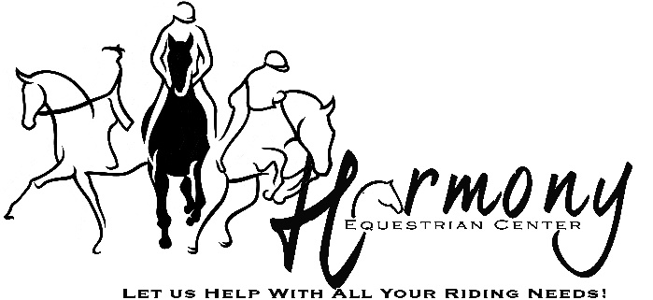

Summer Programs
661 Farmers Road – Fincastle, VA 24090
978-618-3273
stacey@harmonyequestriancenter.com www.harmonyequestriancenter.com

Looking to expand your horse knowledge? Interested in spending more time with the horses? Then join us for our summer camps. HEC will be offering three weeks of Horse Crazy Kids for kids ages 5 – 12 & one week of Equestrian Camp for advance riders. We are also excited to be joining once again with Camp Bethel to offer four weeks of horseback riding for campers-thus offering a traditional camp experience for participants.

HORSE CRAZY KIDS

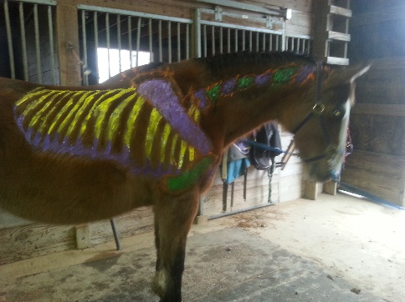
If your child is looking to spend time with horses this summer, Harmony Equestrian Center, LLC’s Horse Crazy Kids Camp is just what you are looking for. Horse Crazy Kids is a half-day summer camp where kids can immerse themselves in horses. Camp will run from 8AM to 12:30PM Monday through Friday. During the week, students will learn basic stable management, horsemanship, ride every day, and have a ton of fun. At the end of the week, there will be a show to demonstrate the riding skills students learned during the week.
Horse Crazy Kids is open to all kids ages 5 – 12 regardless of experience.

What to bring:
- Long pants for riding; shorts may be worn when not riding.
- Boots/sturdy shoes with a 1-inch heel
- ASTM/SEI approved safety helmet
- Snack, water, & lunch
- Sunscreen

Cost: $60/day/ student;
$260 per student for one week;
$250 per student per week for two weeks; $240 per student per week for three or more weeks.
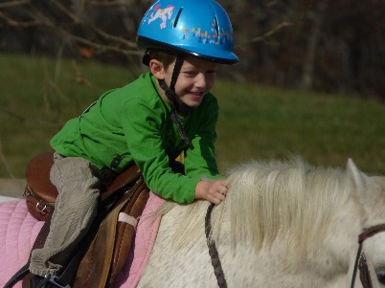
A $50 non-refundable deposit per student per week is required to secure your spot with the balance due the first day of your child’s camp week. $50 discount for boarders/lessees using their horse.

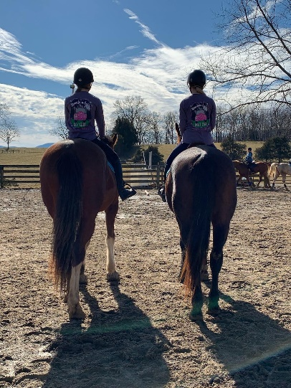
Equestrian Camp
For those riders that are looking for a more advance, specialized focus we will be offering the Junior Equestrian Program. We will work on dressage, stadium jumping, and cross country, videoing and analyzing rides, working on endurance and strength. Cost is $300 and camp will be from 8-3. Riders will ride twice on some days. On the final day of camp, the students will perform a riding demonstration for family and friends.

Camp Bethel
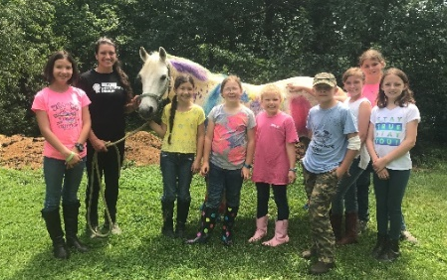
Harmony Equestrian Center, LLC will once again be offering a specialty camp through Camp Bethel. Campers will come to HEC two-four days from 8:30-11:30 for horsemanship, stable management, and riding classes. The rest of the day will be spent in a traditional camping experience at Camp Bethel. Dates for these camps are: June 20-25, June 27-July 2, and July 4-9. Camp Too Sweet: July 11-16
For more information and to register, please contact Camp Bethel at http://www.campbethelvirginia.org or campbetheloffice@gmail.com.
